Using below link you can find a sample project Link (Online Store Project)

<http://toolsqa.com/java/maven/configure-selenium-continuous-integration-maven/>

Download Sample Project from

https://onedrive.live.com/?id=7406B90944A93885%21647&cid=7406B90944A93885

BDD : Behaviour driven Development—bridge between BA and developer

Various tools in Market

* Cucumber
* Jbehave
* Nbehave
* Specflow

Gherkin Syntax

1. Feature
2. Background
3. Scenario
4. Given
5. Then
6. When
7. And
8. But
9. Scenario Outline
10. Examples
11. Scenario Templates

Sample Syntax:--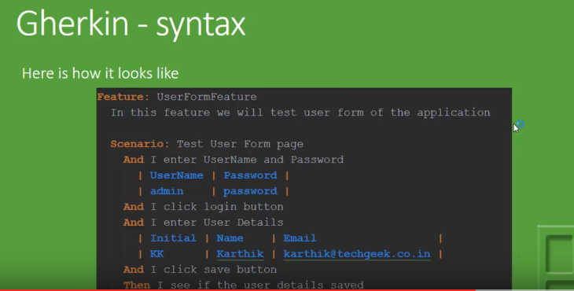

Difference between BDD and Traditional Automation

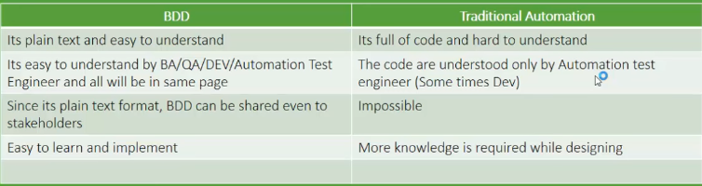

Jars for Cucumber

* Cucumber Core
* Cucumber Java
* Cucumber jvm
* Cucumber –java deps
* Gherkin
* Selenium Related Jars

Install Java, Eclipse, Firefox, IE 8, Cucumber on my machine

Run One script using selenium and cucumber for IE – do this activity first thing in morning… This will yield some confidence for me towards Automation buddy..

**JavaScript**

Evaluating Xpaths

WebElement value = (WebElement) Driver.executeScript("return document.evaluate( '//body//div/iframe' ,document, null, XPathResult.FIRST_ORDERED_NODE_TYPE, null ).singleNodeValue;");

Syntax

document.evaluate( xpathExpression, contextNode, namespaceResolver, resultType, result );

* ***xpathExpression:****A string containing the XPath expression to be evaluated.*
* ***contextNode:****A node in the document against which the xpathExpression should be evaluated, including any and all of its child nodes. The document node is the most commonly used.*
* ***NamespaceResolver:****A function that will be passed any namespace prefixes contained within xpathExpression which returns a string representing the namespace URI associated with that prefix.*
* ***resultType:****A constant that specifies the desired result type to be returned as a result of the evaluation. The most commonly passed constant is XPathResult.ANY_TYPE which will return the results of the XPath expression as the most natural type.*
* ***result:****If an existing XPathResult object is specified, it will be reused to return the results. Specifying null will create a new XPathResult object*

Finding Element:

Driver.findElementById("Id of the element");

WebElement searchbox = null;

searchbox = (WebElement) ff.executeScript("return document.getElementById('gsc-i-id1');", searchbox);